

**NAVIG8 ENGINE WEBSITE**

**USER GUIDES**

**Version: 1.2**

**Date: 06th October, 2020**

**Author: Dinh Duong**

**Table of Contents**

**1.** **Login Credentials:** 4

**2.** **Menu** 4

**3.** **Header** 5

**4.** **Footer** 6

**5.** **Page** 8

**5.1.** **Home page** 8

**5.2.** **Fuel Price page** 9

**5.3.** **Suppliers page** 9

**5.4.** **How It Works page** 10

**5.5.** **Data page** 10

**5.6.** **Planning page** 11

**5.7.** **Accessibility page** 11

**5.8.** **Disclaimer page** 12

**5.9.** **Privacy Policy page** 12

**5.10.** **Terms & Conditions Of Customer Portal Use** 13

**6.** **Contact Forms** 14

**7.** **Twitters** 14

**Image List**

Image 1: Login screen 4

Image 2: Menu screen 4

Image 3: Header screen 5

Image 4: Header screen (2) 5

Image 5: Footet screen 6

Image 6: Footer screen (2) 6

Image 7: Footer screen (3) 7

Image 8: Footer screen (3) 7

Image 9: Menu page 8

Image 10: Home page screen 8

Image 11: Fuel Price page screen 9

Image 12: Supplier page screen 9

Image 13: How It Works page screen 10

Image 14: Data page screen 10

Image 15: Planning page screen 11

Image 16: Accessibility page screen 11

Image 17: Disclaimer page screen 12

Image 18: Privacy Policy page screen 12

Image 19: Terms & Coditions page screen 13

Image 20: Contact Forms screen 13

Image 21: Twitters screen 14

# Login Credentials:

* Username1: william/navig8group (default password)
* Username2: robmaye/navig8group (default password)
* Username3: thomasstott/password is the current password on engine.online

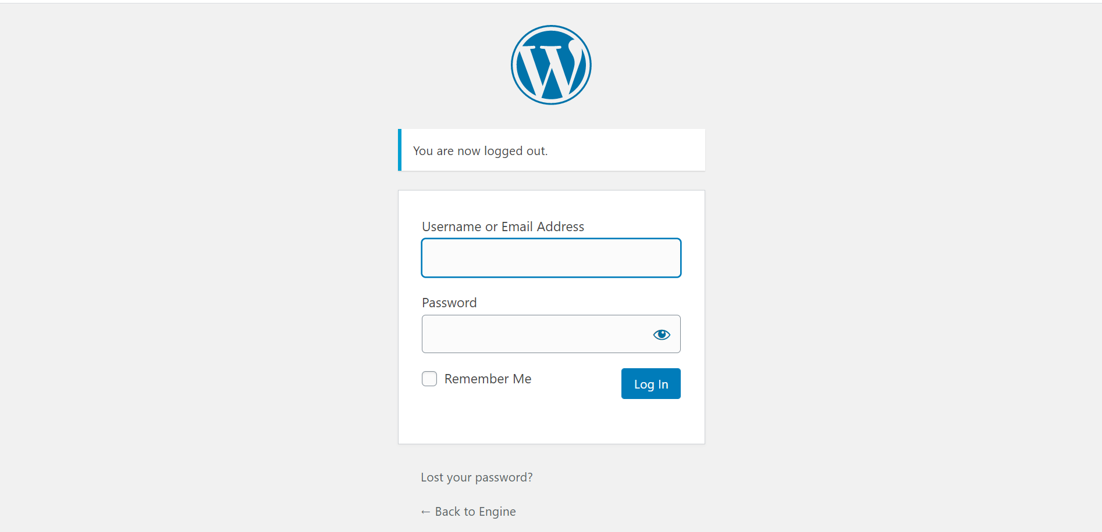

Image 1: Login screen

1. **Menu**

* Login to admin 🡪 Appearance 🡪 Menus

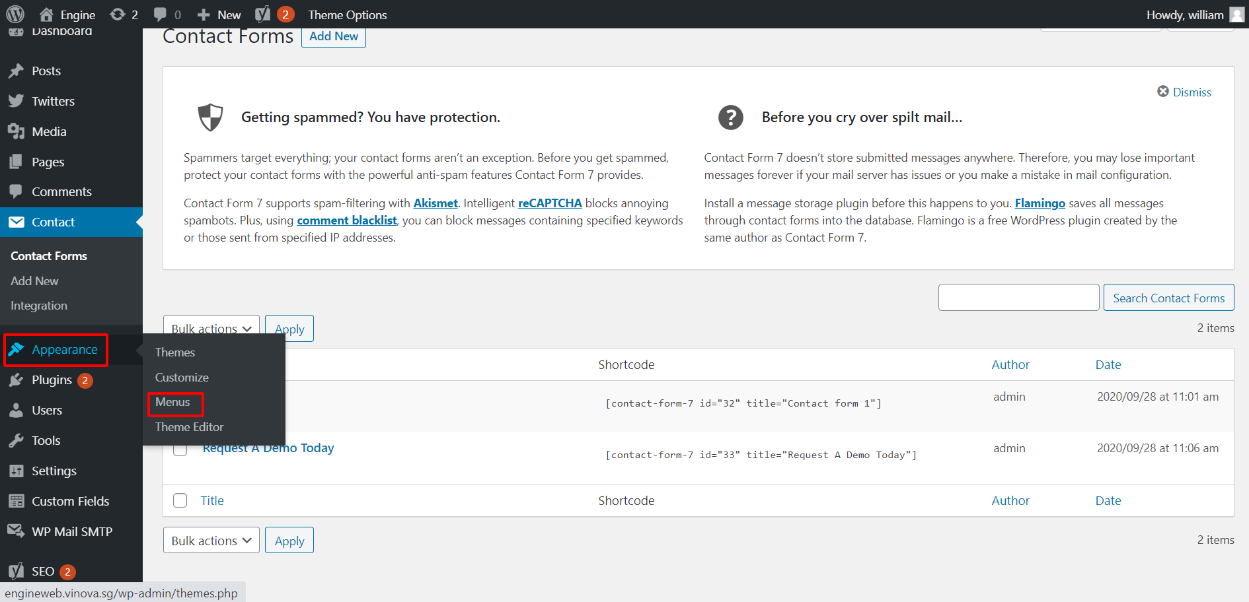

Image 2: Menu screen

* Please kindly explore the video below for more detail: <https://www.loom.com/share/15b22ff8f53345a9b535533ce3cf77df>

1. **Header**

* Login to admin 🡪 Theme Options -> Header

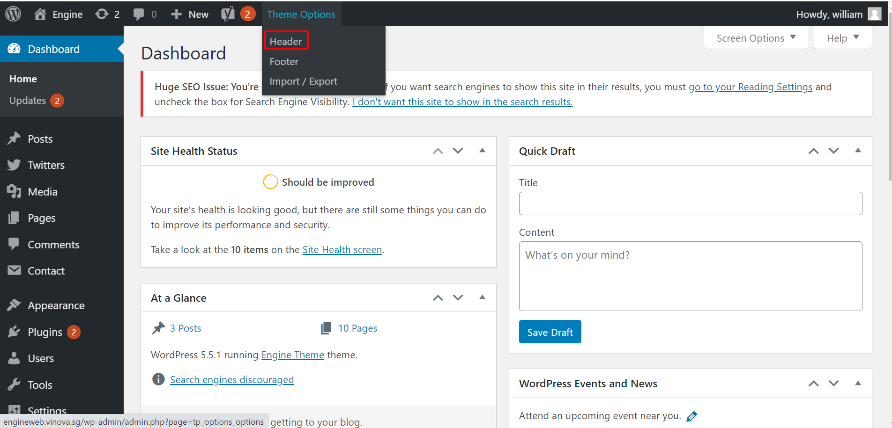

Image 3: Header screen

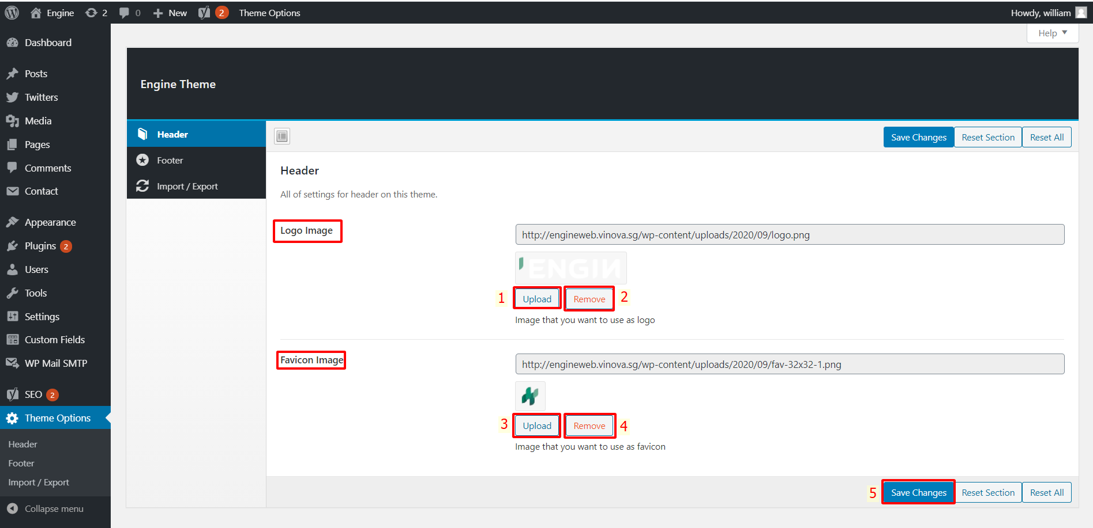

Image 4: Header screen (2)

* Upload Logo Image (1) 🡪 Save Changes (5)
* Remove Logo Image (2) 🡪 Save Changes (5)
* Upload Favicon Image (3) 🡪 Save Changes (5)
* Remove Favicon Image (4) 🡪 Save Changes (5)

1. **Footer**

* Login to admin 🡪 Theme Options 🡪 Footer

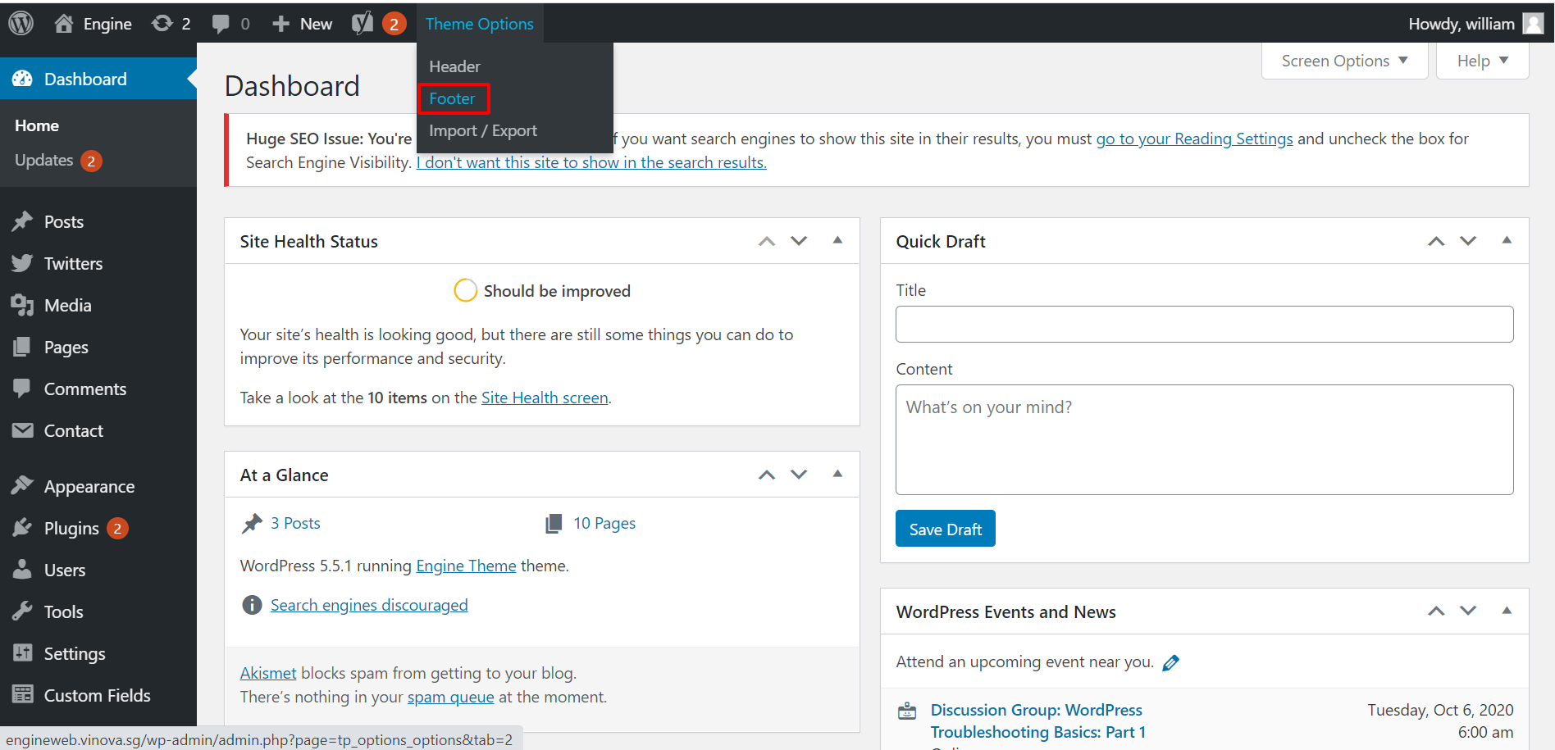

Image 5: Footet screen

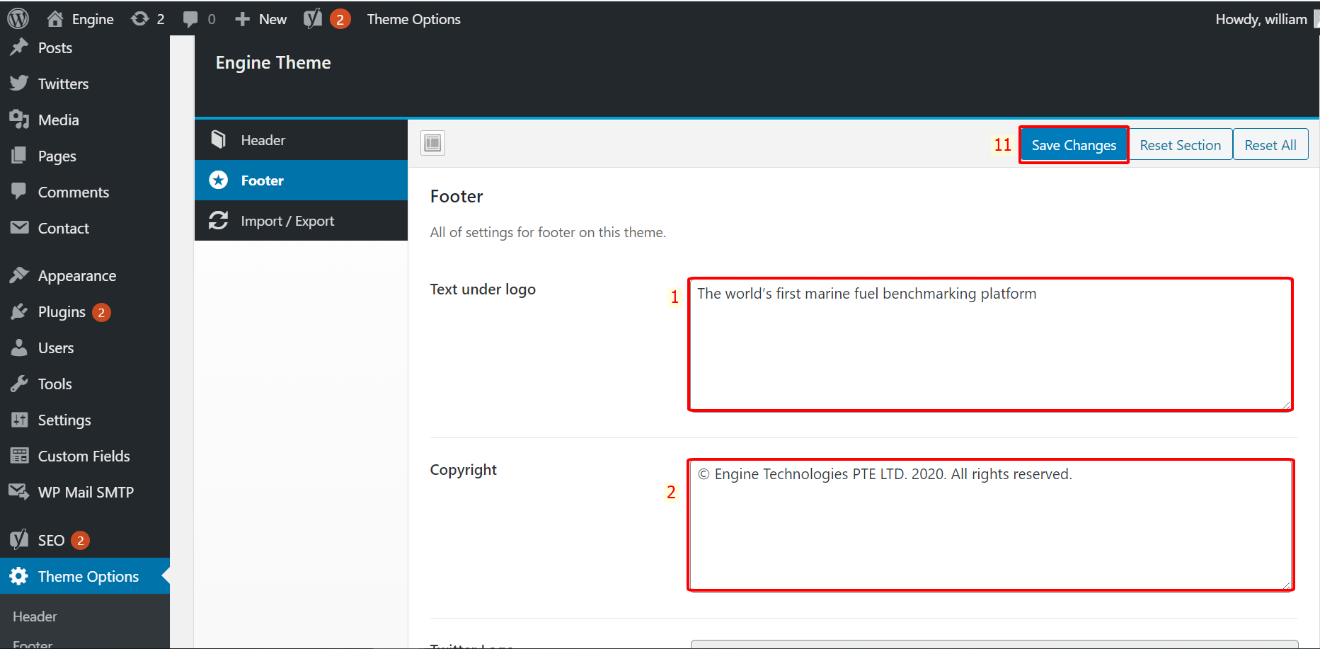

Image 6: Footer screen (2)

* Edit Text Under Logo (1) 🡪 Save Changes (11)
* Edit Copyright (2) 🡪 Save Changes (11)

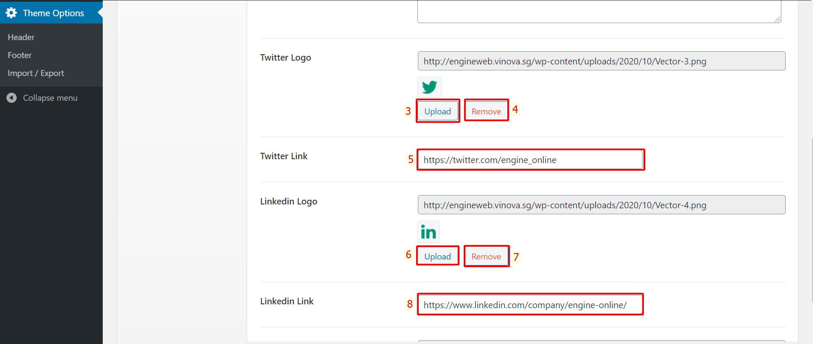

Image 7: Footer screen (3)

* Upload Twitter Logo (3) 🡪 Save Changes (11)
* Remove Twitter Logo (4) 🡪 Save Changes (11)
* Edit Twitter Link (5) 🡪 Save Changes (11)
* Upload Linkedin Logo (6) 🡪 Save Changes (11)
* Remove Linkedin Logo (7) 🡪 Save Changes (11)
* Edit Linkedin Link (8) 🡪 Save Changes (11)

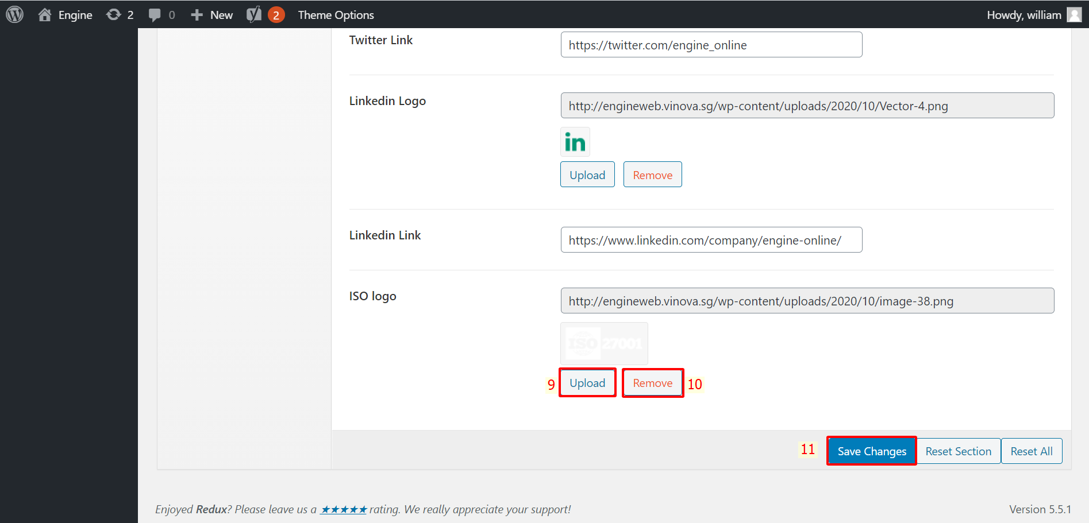

Image 8: Footer screen (3)

* Upload ISO logo (9) 🡪 Save Changes (11)
* Remove ISO logo (10) 🡪 Save Changes (11)

1. **Page**

* Login to admin 🡪 Pages 🡪 All pages

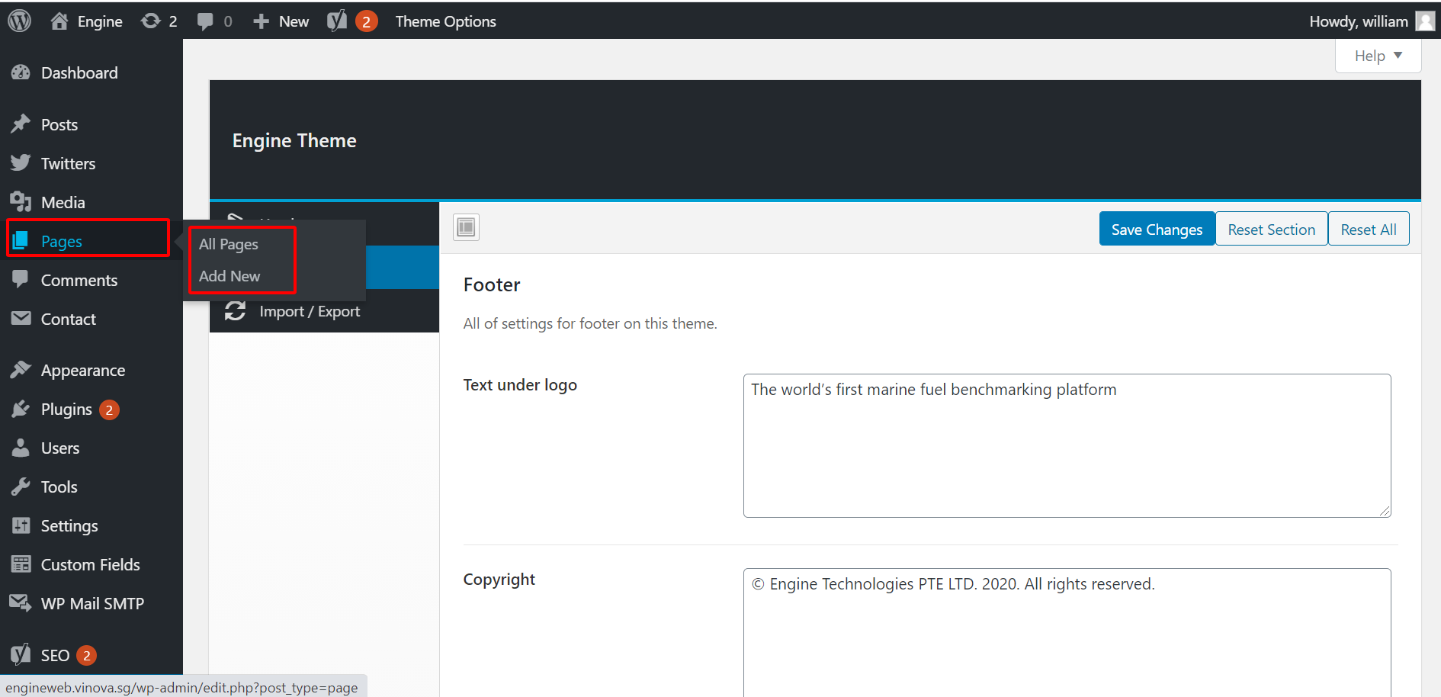

Image 9: Menu page

* 1. **Home page**
* Edit page: Choose Home 🡪 Click Edit

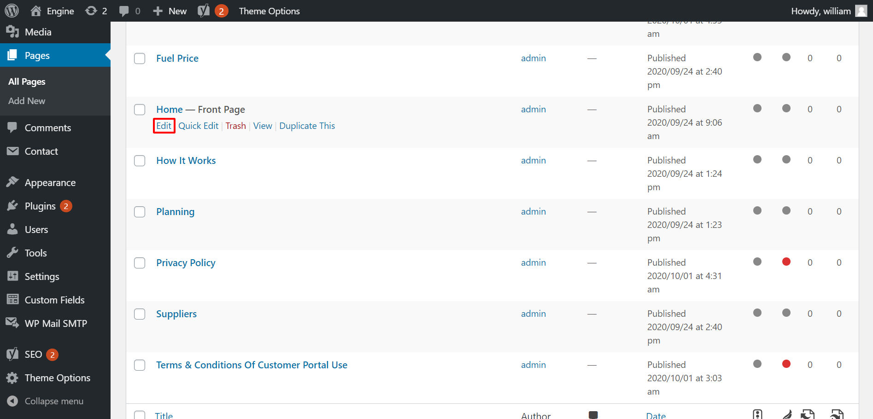

Image 10: Home page screen

* See attached link: <https://www.loom.com/share/eb6def6c5afc4635b69da599b429b1d0>
  1. **Fuel Price page**
* Edit page: Choose Fuel Price 🡪 Click Edit

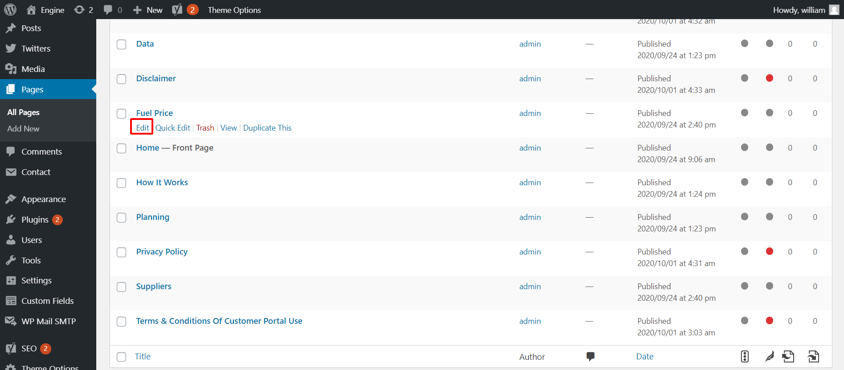

Image 11: Fuel Price page screen

* See attached link: The contact form is like the Home page

<https://www.loom.com/share/c9950b1a1fdd48ecb94d948c370a803c>

* 1. **Suppliers page**
* Edit page: Choose Suppliers 🡪 Click Edit

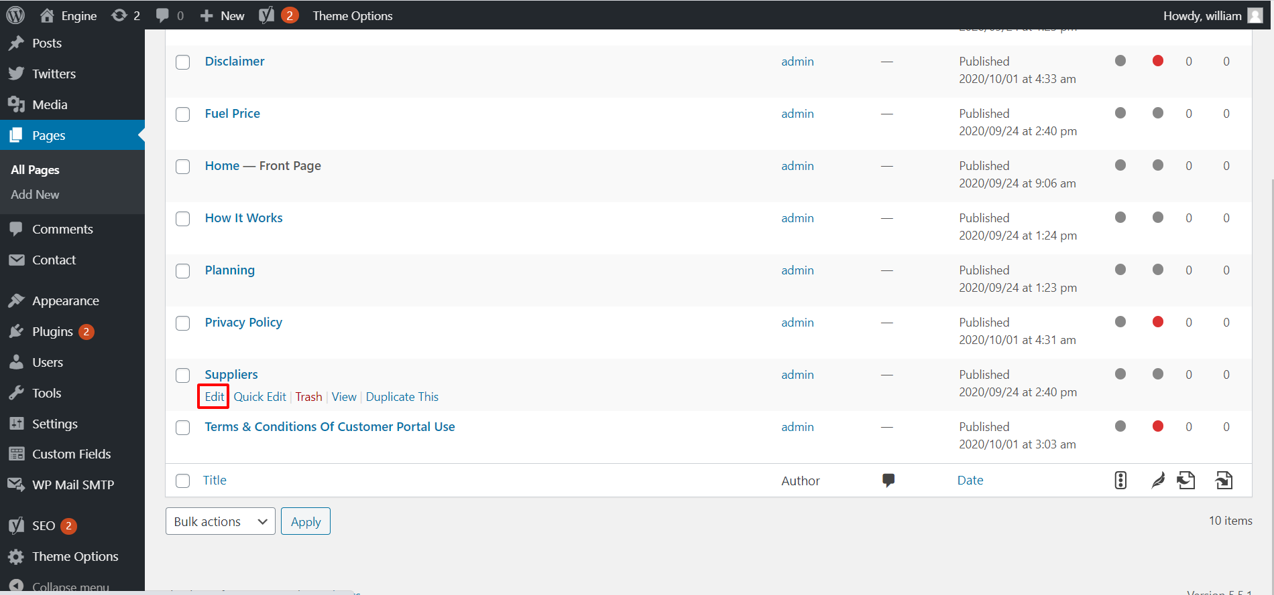

Image 12: Supplier page screen

* See attached link: The contact form is like the Home page <https://www.loom.com/share/d26b2cce14924f26b9fd33a648522f21>
  1. **How It Works page**
* Edit page: Choose How It Works 🡪 Click Edit

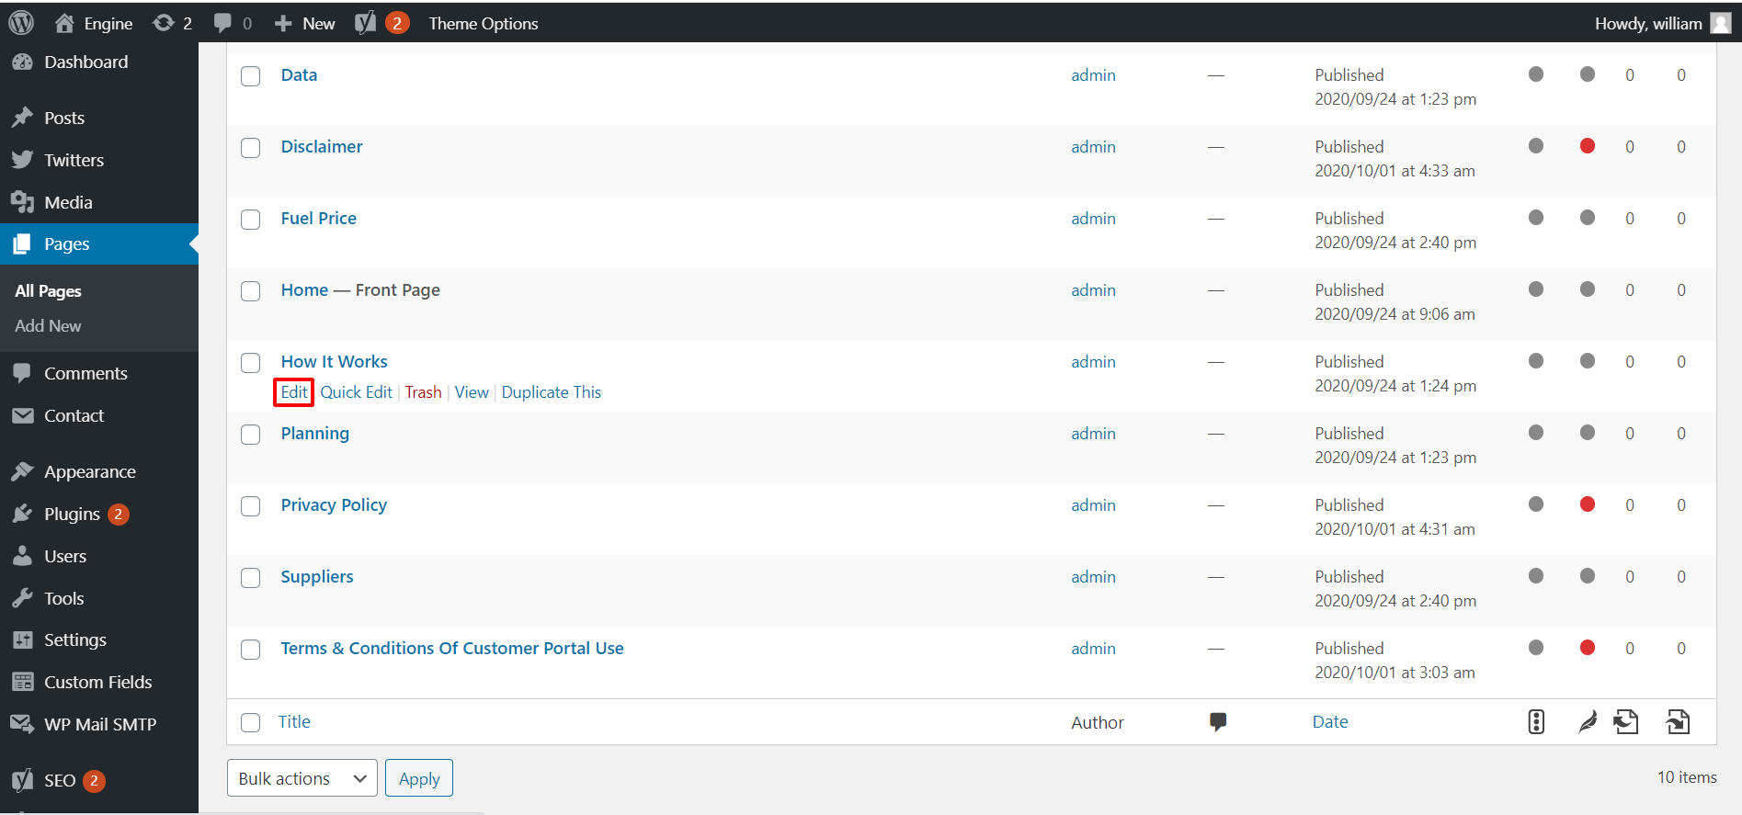

Image 13: How It Works page screen

* See attached link: The contact form is like the Home page

<https://www.loom.com/share/168ee9e885c246f29f07639fcdfd3204>

* 1. **Data page**
* Edit page: Choose Data 🡪 Click Edit

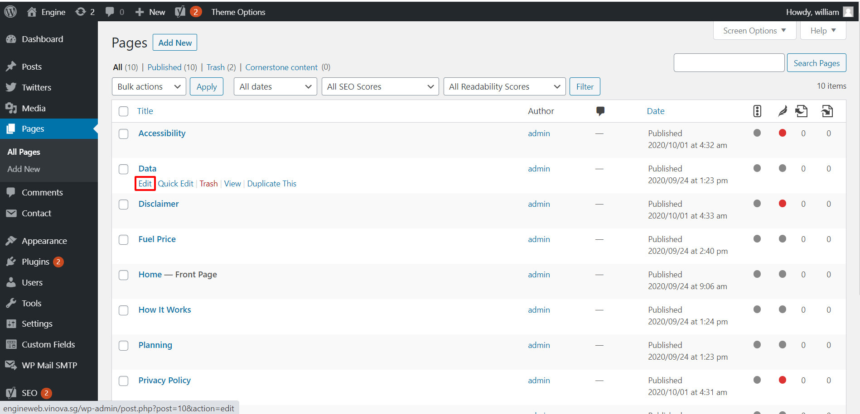

Image 14: Data page screen

* See attached link: The contact form is like the Home page

<https://www.loom.com/share/fbe123f381834aa2b1ef06186c14ddd2>

* 1. **Planning page**
* Edit page: Choose Planning 🡪 Click Edit

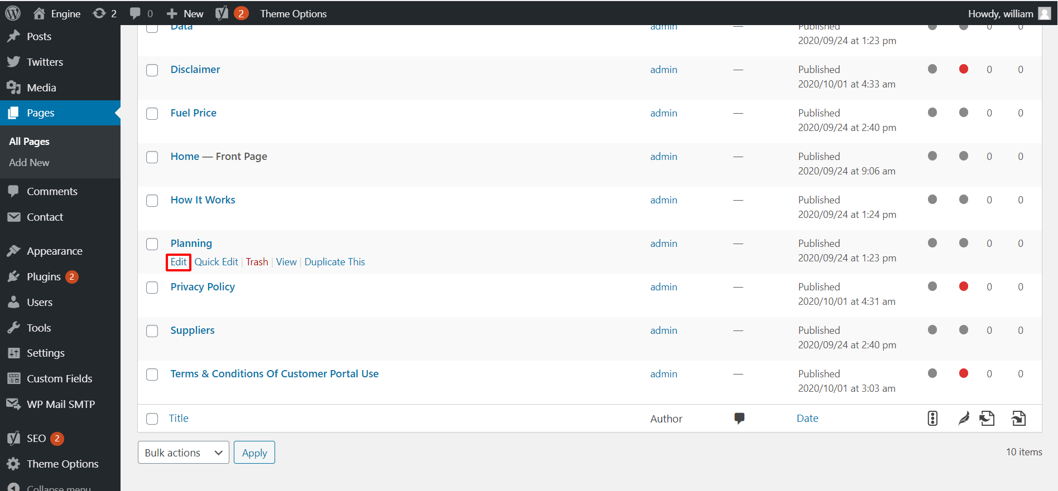

Image 15: Planning page screen

* See attached link: The contact form is like the Home page

<https://www.loom.com/share/a06b935848bd40d08f99c77cc39e5208>

* 1. **Accessibility page**
* Edit page: Choose Accessibility 🡪 Click Edit

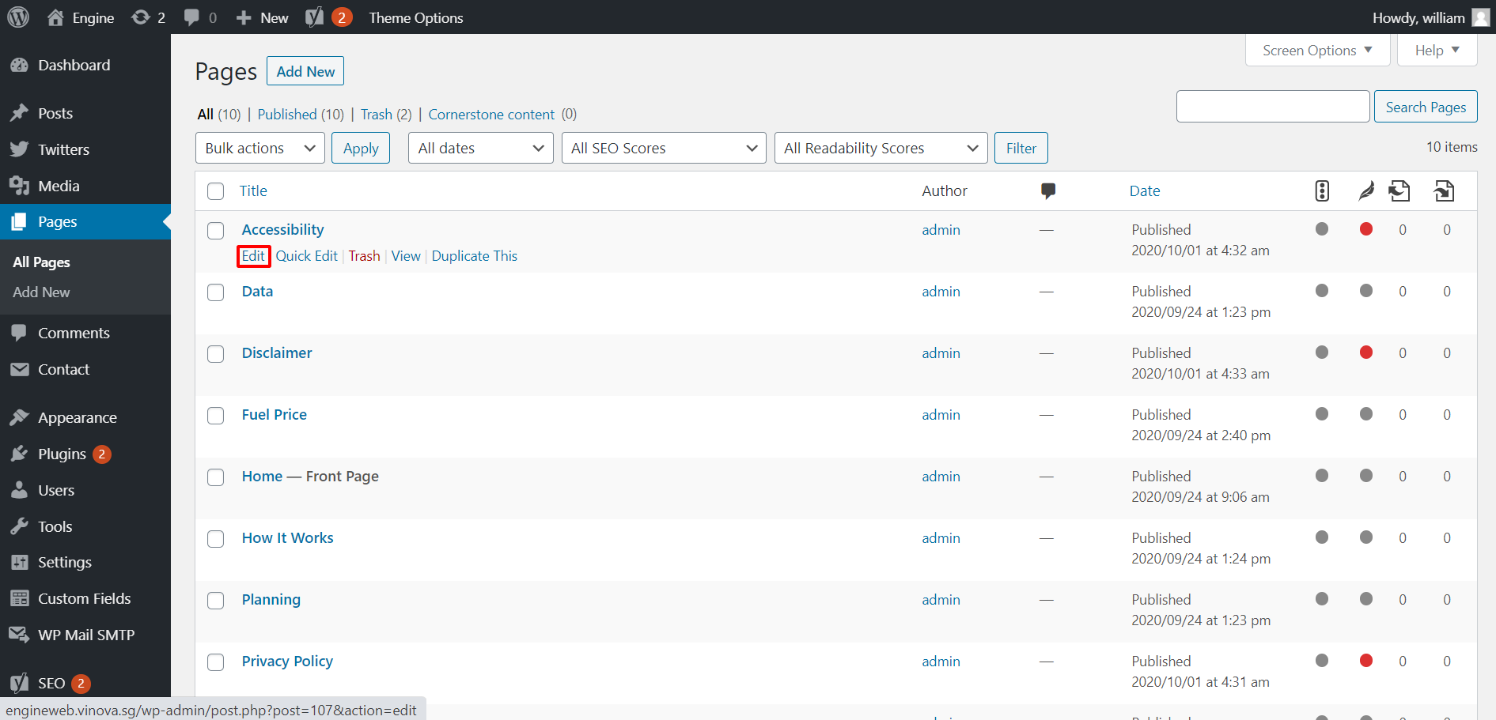

Image 16: Accessibility page screen

* See attached link: The contact form is like the Home page

<https://www.loom.com/share/04f6bdffb5e3405cb6fb2ba70aacb03c>

* 1. **Disclaimer page**
* Edit page: Choose Disclaimer 🡪 Click Edit

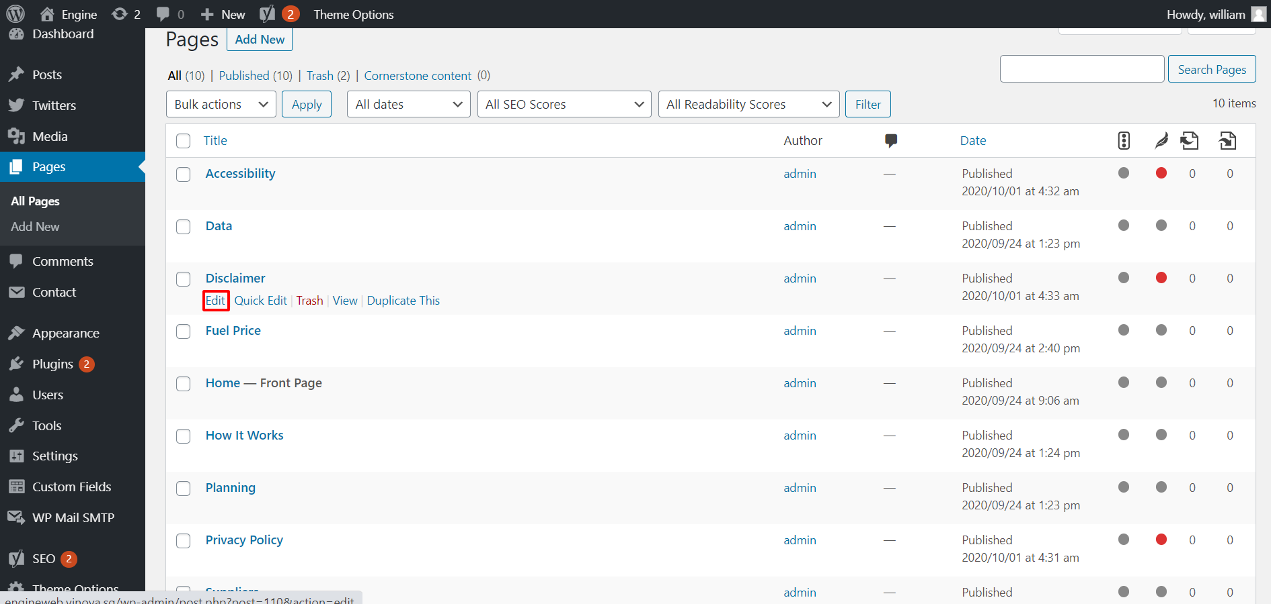

Image 17: Disclaimer page screen

* See attached link: The contact form is like the Home page

<https://www.loom.com/share/a618cf6fffd24ea9babcd3398cce06a6>

* 1. **Privacy Policy page**
* Edit page: Choose Privacy Policy 🡪 Click Edit

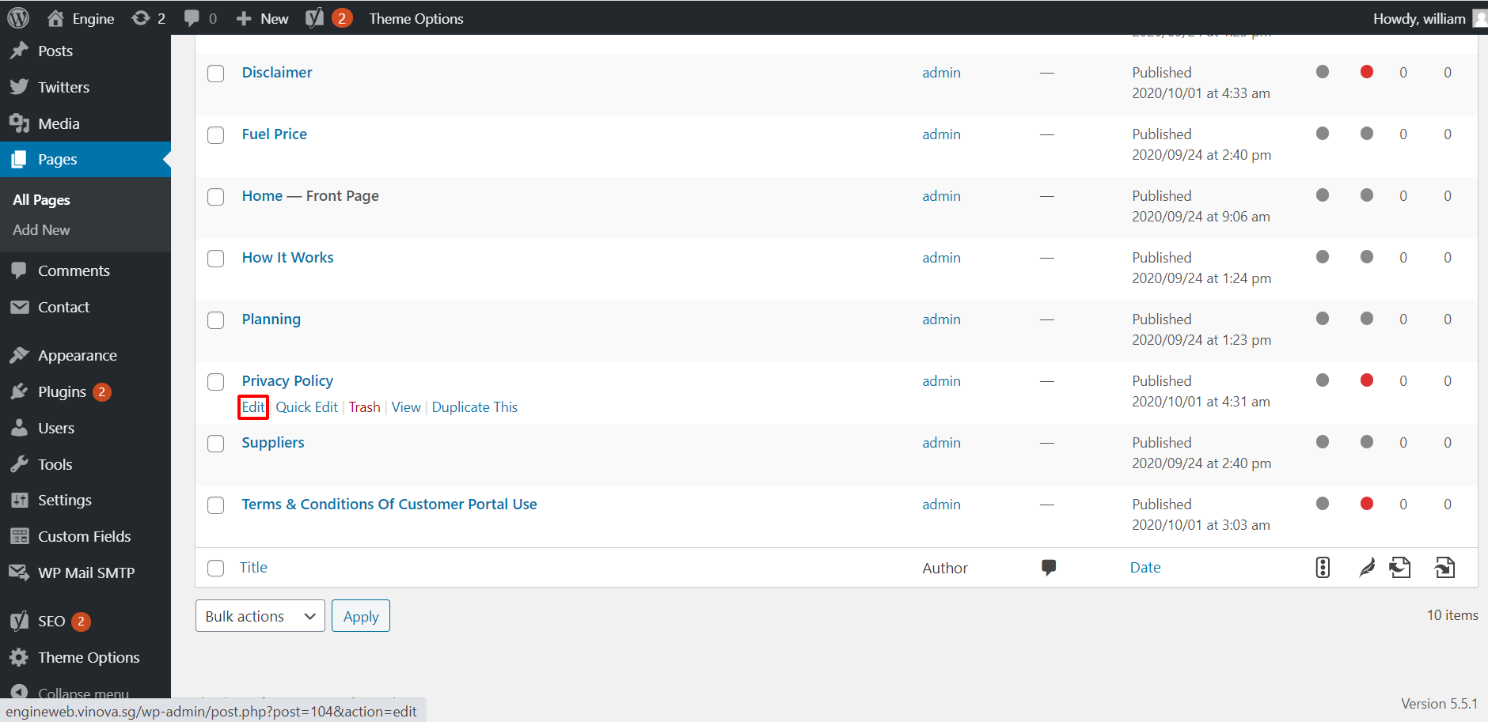

Image 18: Privacy Policy page screen

* See attached link: The contact form is like the Home page

<https://www.loom.com/share/c6fbe68f813e4bf6883257e0a939f22b>

* 1. **Terms & Conditions Of Customer Portal Use**
* Edit page: Choose Terms & Conditions Of Customer Portal Use 🡪 Click Edit

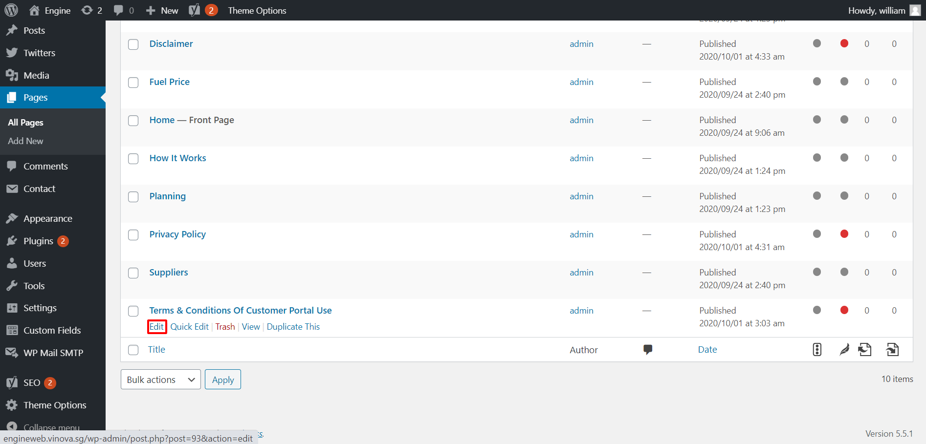

Image 19: Terms & Coditions page screen

* See attached link: The contact form is like the Home page

<https://www.loom.com/share/a6c975cd1965494fb0eb88a339fd5d50>

1. **Contact Forms**

* Login to admin 🡪 Contact 🡪 Contact Forms

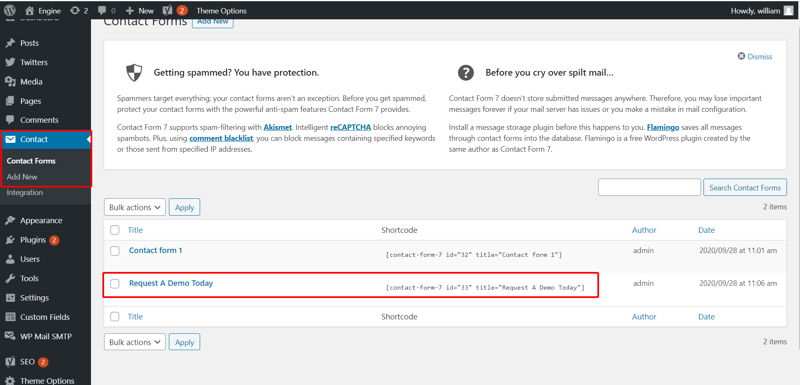

Image 20: Contact Forms screen

* See attached link: <https://www.loom.com/share/1a6d585ec65643d085cb86ae29bf1c38>

1. **Twitters**

* Login to admin 🡪 Twitters

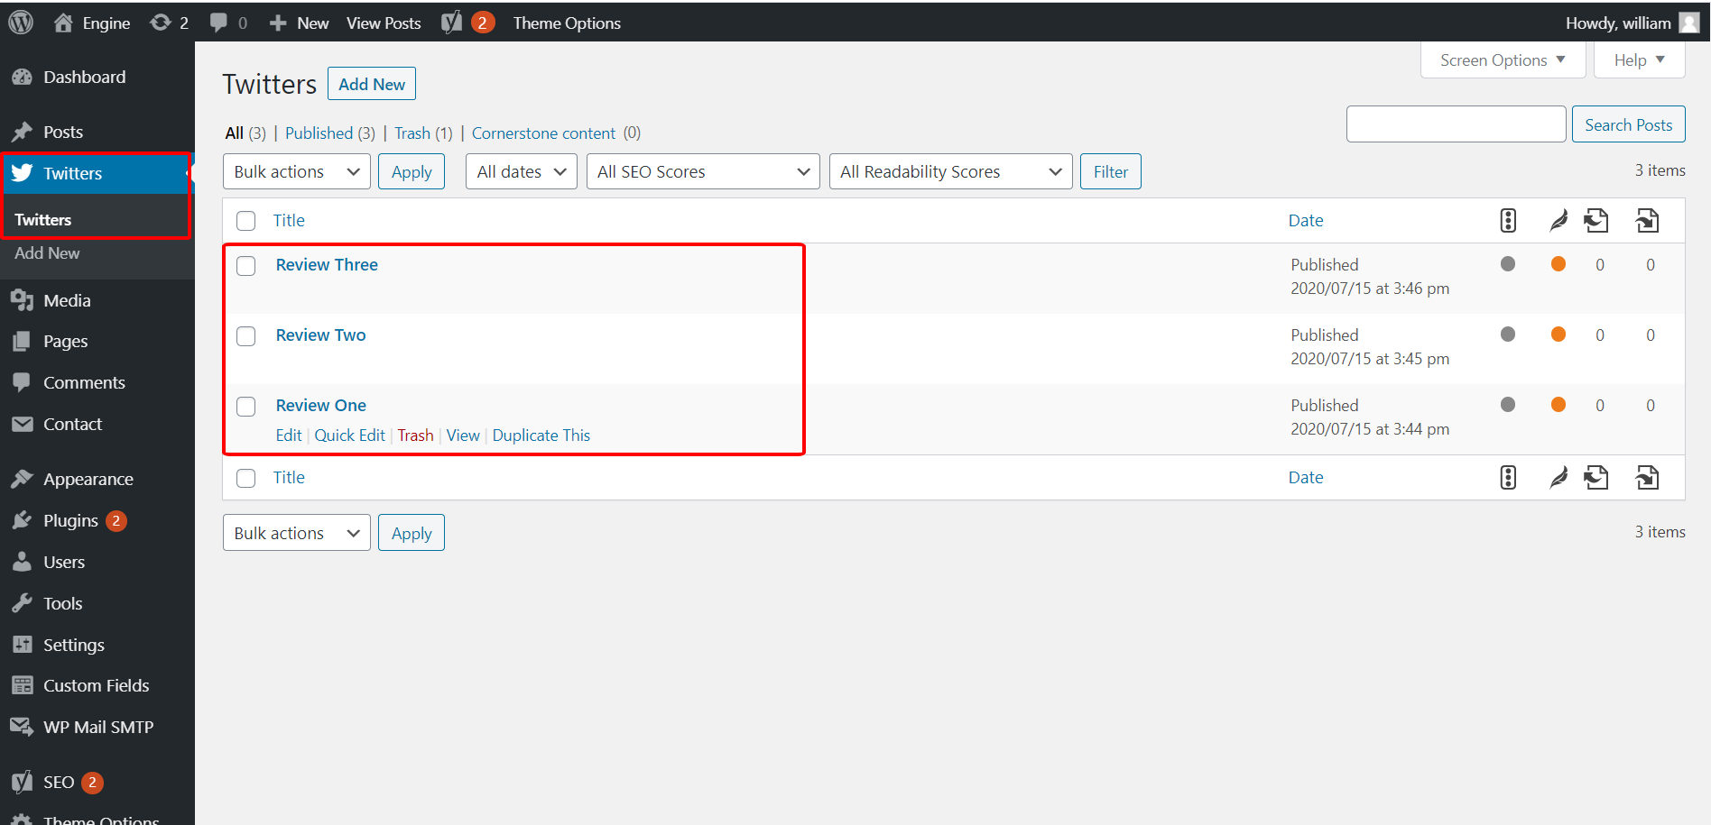

Image 21: Twitters screen

* See attached link: <https://www.loom.com/share/c8b16a645f1e4e8f837eb1af71918faa>